**Project Design Phase-II**

**Technology Stack (Architecture & Stack)**

|  |  |
| --- | --- |
| Date | 03 October 2022 |
| Team ID | PNT2022TMID10364 |
| Project Name | Project – CAR RESALE VALUE PREDICTION |
| Maximum Marks | 4 Marks |

**TECHNOLOGICAL ARCHITECTURE FOR CAR RESALE VALUE PREDICTION:**

The deliverable shall include the architectural diagram as below and the information as per the table 1 and 2

Example: Order processing during pandemics for offline mode

Reference: https://developer.ibm.com/patterns/ai-powered-backend-system-for-order-processing-during-pandemics/

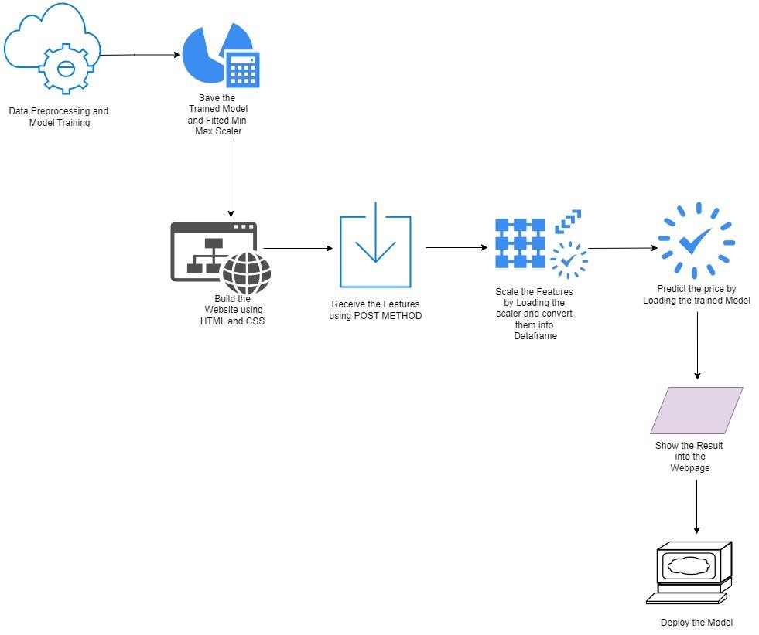

**Table-1 : Components & Technologies:**

|  |  |  |  |
| --- | --- | --- | --- |
| **S.No** | **Component** | **Description** | **Technology** |
| 1. | User Interface | Web UI | HTML and CSS |
| 2. | Application Logic-1 | Worked with datasets composed of details about cars | Datasets and task formalization using python |
| 3. | Application Logic-2 | Pre –process the data and make it suitable for machine learning | Encoding categorical variables |
| 4. | Database | Containing the details about car like fuel type,price etc., | Datasets |
| 5. | Cloud Database | Database Service on Cloud | Google cloud platform (GCP) |
| 6. | File Storage | File storage requirements | Local file systems |
| 7. | Machine Learning Model | Used to predict the best resale value model | Linear Regression model, Lasso Regression etc., |
| 8. | Infrastructure (Cloud) | Application Deployment on Cloud  Cloud Server Configuration : Enable developers to build, run and operate applications in the cloud | Heroku platform |

**Table-2: Application Characteristics:**

|  |  |  |  |
| --- | --- | --- | --- |
| **S.No** | **Characteristics** | **Description** | **Technology** |
| 1. | Open-Source Frameworks | Software library built for machine learning that enable developers to create a best model | Tensor Flow |
| 2. | Security Implementations | Used to detect unknown attacks with no established signature | Malware analysis |
| **S.No** | **Characteristics** | **Description** | **Technology** |
| 3. | Scalable Architecture | It can handle any amount of data and perform many computations | HTML , CSS and Python flask framework |
| 4. | Availability | Uninterrupted services must be available in all the time except the time of server updation. | Classification and regression model |
| 5. | Performance | Multiple users can access the web application. | Firebase Machine learning |